SRMS Jazz Ensemble Audition Material 2019
Three Memorized Scales • Jazz Ensemble Etude B • Sight Reading
Scales: Students will be asked to perform one of the following scales from memory: Concert Bb, Eb, and F blues scale using the pattern below in one octave. Students who perform in two octaves will not be penalized or given extra credit.

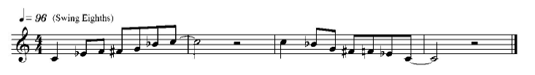

Etude: A jazz etude composed by Mr. Gregg Winters has been created specifically for this audition. Chorus one and four play the written melody, chorus two, play the ensemble hits, and chorus three improvise (optional). Should you choose not to attempt an improvised solo, you will count through that section and come back in on the fourth chorus. Each student will play along with a recording, please ask your band director how to access it online.
Guitar/Piano: Chorus one and four play the written melody. Chorus two, comp the chords. Chorus three, improvise (optional). If you choose not to attempt an improvised solo, you will count through that section and come back in on the fourth chorus.
Bass: Chorus one and four play the written melody. Chorus two walk a bass line over the chord progression. Chorus three, improvise (optional). If you choose not to attempt an improvised solo, you will count through that section and come back in on the fourth chorus.
Drum set: Chorus one and four play time. Chorus two set up and play the ensemble hits. Third chorus improvise (optional). If you choose not to attempt an improvised solo, you will keep time through the third chorus. Perform entire etude 3 times, first swing, then Latin groove, then a funk groove.
Sight Reading: All participants will be required to sight read a 4-measure exercise.

